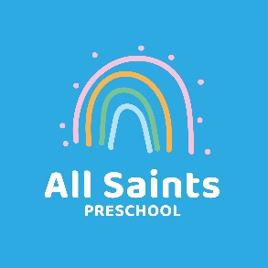
NLCA, Aperdele Road, Leatherhead KT22 7QT
Panco Policy
PANCO = Physical Activity and Nutrition Co-ordinator
All Saints Preschool regard snack and meal times as an important part of the day.
Eating represents a social time for children and adults and helps children to learn about eating healthily and independence skills. We have a named PANCO who is responsible for co-ordinating our approach to nutrition, healthy eating and physical activity. Our aim is to help children understand the benefits of healthy eating and the impact of physical activity on their bodies. We want to do this in a way that engages all staff in a shared ethos and also includes the families of the children in our care.
It is important for children even of a young age to develop an understanding of what makes a healthy, balanced diet and an enjoyment of eating and preparing foods with their families.
Our daily snack bar offers a wide range of fruits, vegetables and healthy snacks. Every child brings a donation towards the snack bar to each session. Every morning, two children help an adult to prepare the food for the snack bar. Children are chosen on the basis of a rota which makes sure every child has an opportunity to take part.
Before a child starts to attend the setting, we find out from parents and carers their children’s dietary needs and preferences, including any allergies. This information is stored in the Information Folder and is also displayed at the snack bar for all staff to see. It is the PANCO’s responsibility to ensure that this information is kept up to date.
We have a healthy lunchbox policy which is explained to parents when their children start at preschool. Staff check lunchboxes daily to ensure that requirements are being met. This is particularly important when accounting for allergens. Parental engagement on this is vital.
Physical development is a prime area in the EYFS and we recognise this. Staff understand the importance of children having a solid grounding in the prime areas in order to achieve in the secondary areas. Children are provided with various opportunities to engage in a variety of physical activities on a daily basis. We also have extra sessions termly which include yoga and dance.
Dental hygiene is a topic we discuss regularly with the children, using resources to help engage parents in promoting its importance at home. We try to arrange visits from local dentists once a year to engage the children in a way that is fun and informative.
All staff understand the importance of Physical Development as a prime area of the EYFS and recognise that physical activity, good nutrition and hygiene are all important aspects of this. They carefully plan and implement activities to help the children learn, engage and develop and are adept at spotting areas requiring further development and bringing these to the attention of the PANCO and the Manager.

March 2022
Review date March 2023

