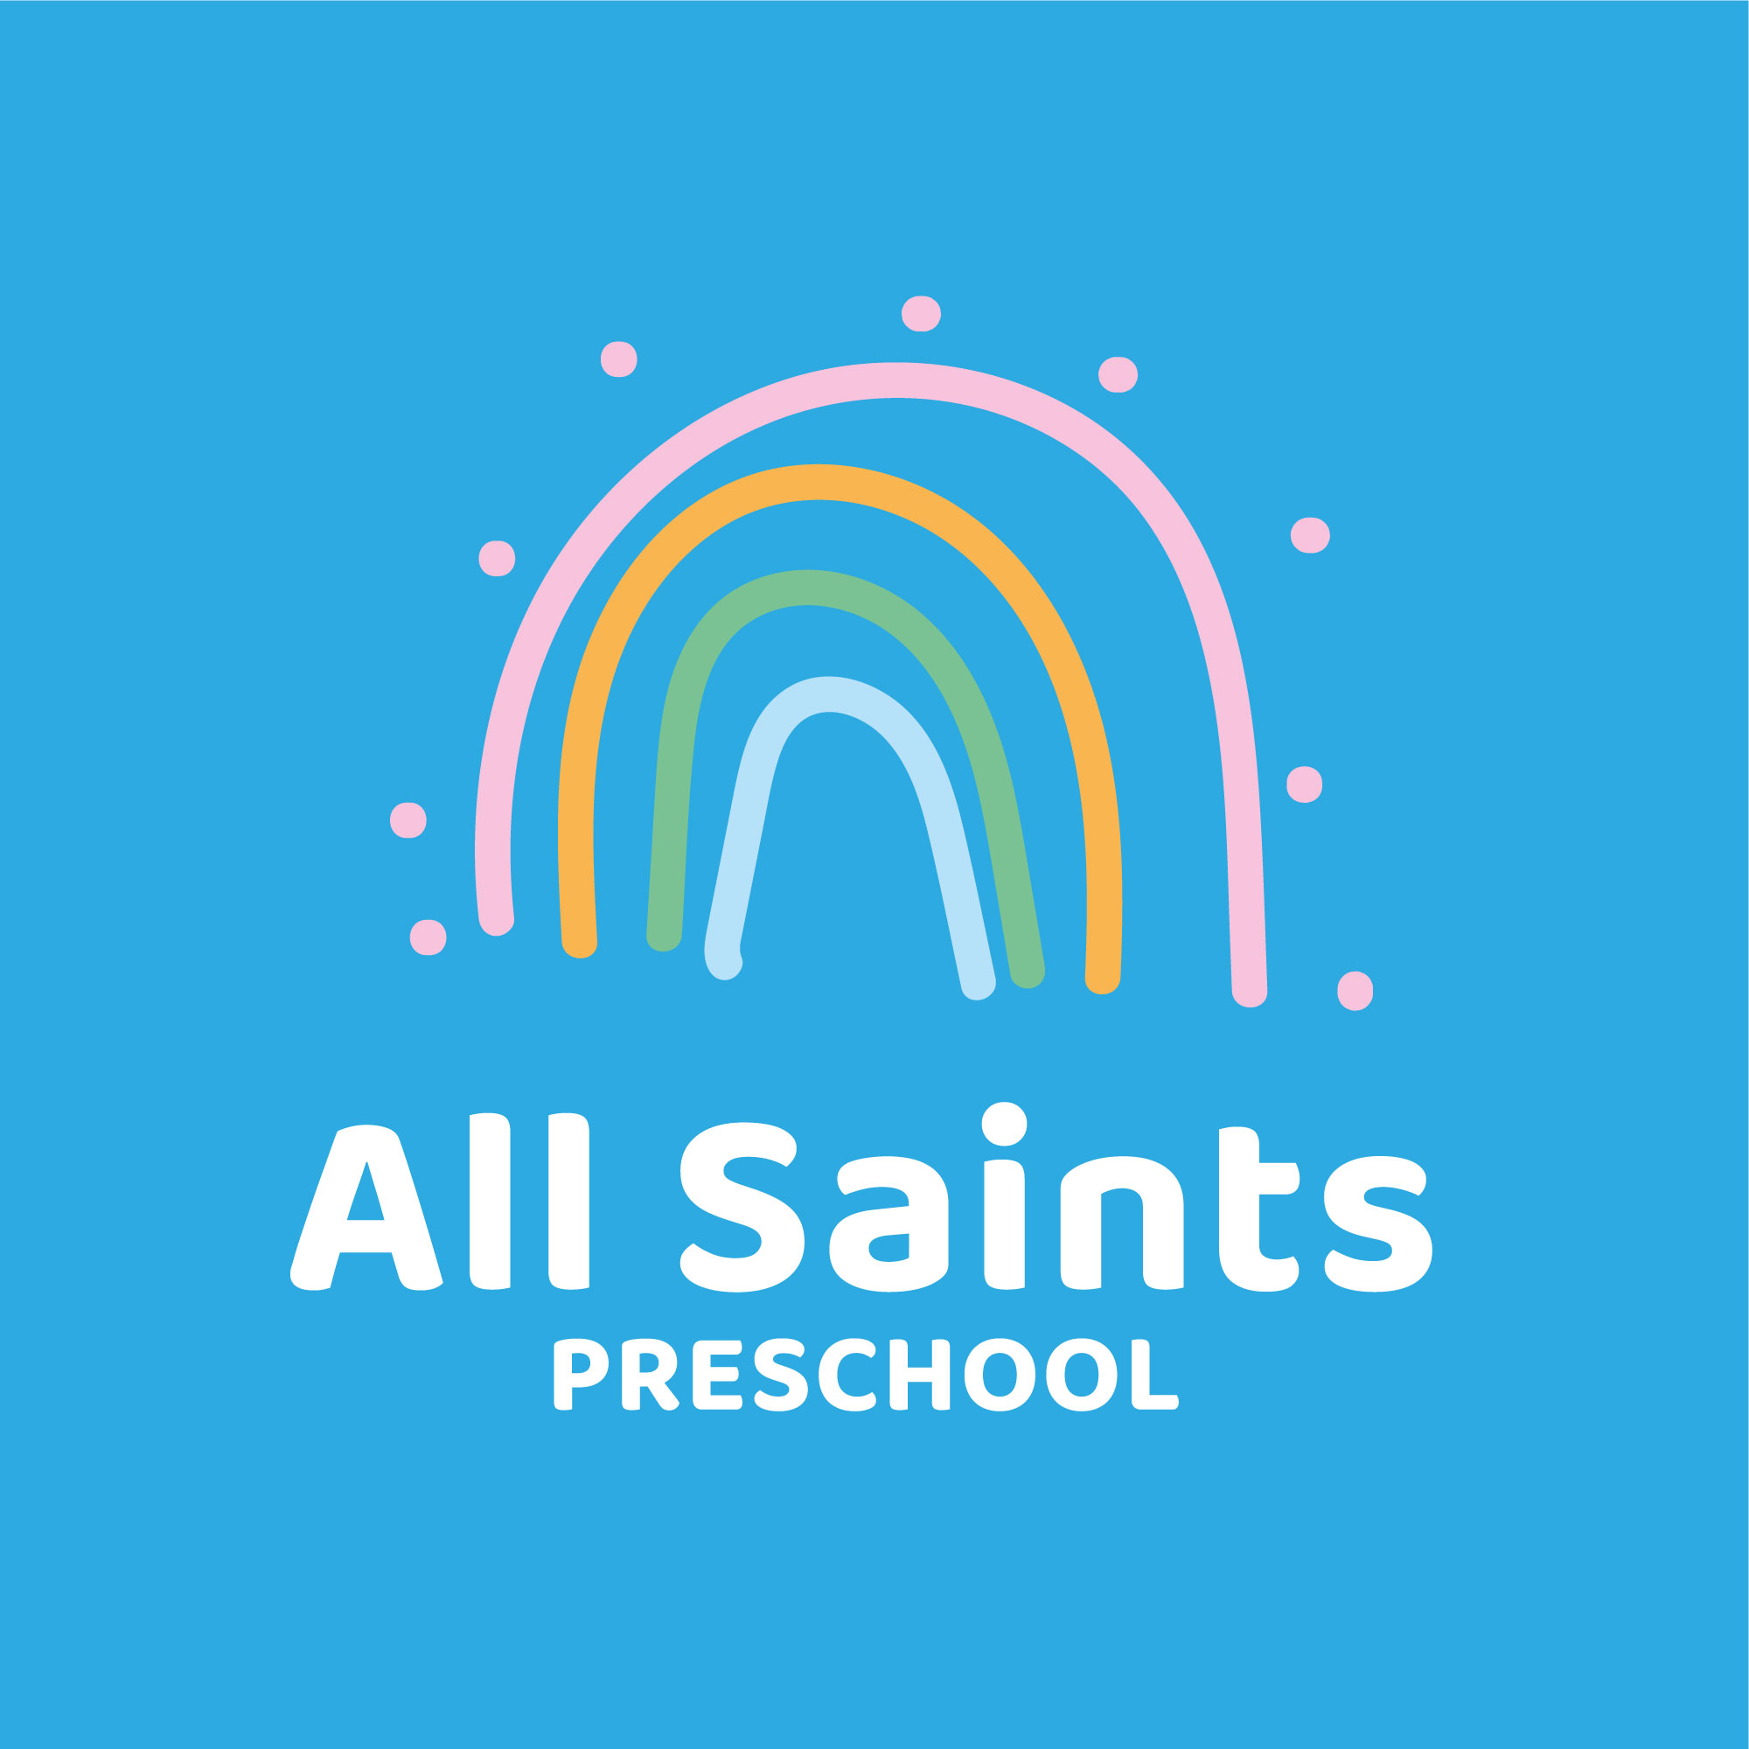
Lunchbox Policy

Statement of intent.

To ensure that children eat a range of healthy foods whilst at preschool. Promoting good health and dental hygiene. Reducing the risk associated with allergies.

- Children staying all day, staying for lunch club or attending the afternoon session are required to bring a packed lunch.
- Packed lunches should contain a sandwich with a savoury filling or a suitable alternative along with a piece of fruit/vegetable, a serving of carbohydrate (breadsticks/crisps or similar) and a yoghurt or similar
- Children may bring a drink but no fizzy drinks or sugary drinks please.
- We provide water throughout the day.
- Nuts, products made from and products containing nuts are strictly prohibited to avoid the risk of potentially serious allergic reactions.
- Children should be encouraged to open their own containers and packaging, please help them by providing items they can manage themselves.
- Sweets and chocolate bars are not allowed but the occasional chocolate biscuit or cake as a treat is absolutely fine.
This policy was adopted at a meeting of | All Saints Preschool
Held on (date) | 10 March 2022
Signed on behalf of the Management Committee/Proprietor
Role of signatory (e.g. chairperson etc.)
This policy was reviewed on |  | (date)
continue as necessary |  | (date)

